**Riphah International University, Lahore**

**(Assignment#3)**



**Name: Abdul Rehman Imtiaz**

**Section: BSCS (1C)**

**SAP ID: 46885**

**Subject: Programming Fundamental**

**Submitted to: Miss Aliya**

Question 1: Write outputs of the following segments of code.

|  |  |  |
| --- | --- | --- |
| int main( )         {              increment( ) ;              increment( ) ;              increment( ) ;         }  void  increment( )         {                static int i = 1 ;                cout<< i  ;                 i = i + 1 ;          } | | **Output**:  1,2,3 |
| int x=2;  int y=3;  cout <<(x>y?x:y); | | **Output:**  3 |
| int x = 2;  //Creates integer variable named  x and assigns it value 2.  int *p;  p = &x;  *p = 4;  cout << p;.  cout << *p;  int fun(int *, int*); | | **Output:**  0x6ffe144 |
|  |  | | |
| string convert(string str)  {    for (int i = 0; i < str.length(); i++)    {        if (i == 0 && str[i] != ' ' ||          str[i] != ' ' && str[i - 1] == ' ')      {        if (str[i] >= 'a' && str[i] <= 'z')        {          str[i] = (char)(str[i] - 'a' + 'A');        }      }      else if (str[i] >= 'A' && str[i] <= 'Z')        str[i] = (char)(str[i] + 'a' - 'A');    }      return str;  }   int main()  {    string str = "I am a student of programming fundamentals!";    cout << (convert(str));    return 0;  } | **Output:**  I am a student of programming fundamentals! | | |

**Question 2:**

Write a program to initialize 3 different strings and perform the following functions:

1. Copy string1 into string2
2. Concatenate string1 and string2
3. Calculate and show the total length of string1 after concatenation.

**Code:**

#include<iomanip>

#include<conio.h>

#include<iostream>

#include<string>

using namespace std;

int main()

{

float sum = 1.00;

float i = 2;

do

{

sum = sum + 1 / i;

i = i + 2;

} while (i <= 100);

cout << "sum of series 1+1/2+1/4+1/6+......+1/100 will be:" << sum;

return 0;

}

**Output:**

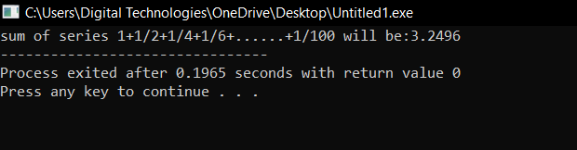

**Question 3:**

Write a program to calculate the sum of the following series using do while loop.

1+1/2+1/4+1/6+1/8+…………………..+1/100

**Code:**

#include<iomanip>

#include<conio.h>

#include<iostream>

#include<string>

using namespace std;

void copy_string(string str1, string str2)

{

str2 = str1;

cout <<"string2 copied from string1 will be:"<< str2<<endl;

}

int length(string c)

{

int length = 0;

for (int i = 0;c[i] != '\0';i++)

{

length++;

}

return length;

}

string concatination(string str1, string str3)

{

string result = str1 + str3;

return result;

}

int main()

{

string str1 = "hello";

string str2 = "";

string str3 = "world";

copy_string(str1,str2);

str1 = concatination(str1, str3);

cout << "string1 after concattination will be: " << str1<<endl;

}

**Output:**

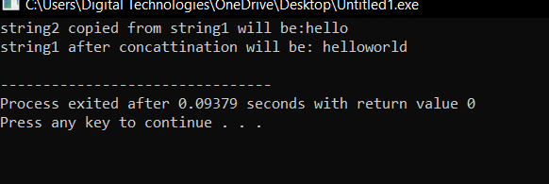

**Question 4:**

Write a program (starting from #include) that repeatedly collects positive integers from the user, stopping when the user enters a negative number or zero. After that, output the product of all positive entries.

**Code:**

#include<iomanip>

#include<conio.h>

#include<iostream>

#include<string>

using namespace std;

int main()

{

int arr[100];

int size = 0;

for (int i = 0;i < 100;i++)

{

int x;

cin >> x;

if (x >0)

{

arr[i] = x;

size++;

}

else

{

break;

}

}

for (int i = 0;i < size;i++)

{

cout << arr[i]<<",";

}

}

**Output:**

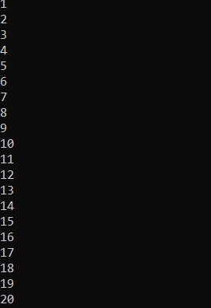

**Question 6:**

The following function uses reference variables as parameters. Rewrite the function so it uses pointers instead of reference variables, and then demonstrate the function in a complete program.

int doSomething(int &x, int &y)

{

int temp = x;

x = y * 10;

y = temp * 10;

return x + y;

}

**Code:**

#include <iostream>

using namespace std;

// Function that uses pointers as parameters

int doSomething(int *x, int *y)

{

int temp = *x;

*x = *y * 10;

*y = temp * 10;

return *x + *y;

}

int main()

{

int a = 6;

int b = 7;

cout << "a: " << a << endl;

cout << "b: " << b << endl;

int result = doSomething(&a, &b);

cout << "result: " << result << endl;

cout << "a: " << a << endl;

cout << "b: " << b << endl;

return 0;

}

**Output:**

